Hyper-V VM setup

2.Setup NAT & StaticRoutes on Routing & remote access

* NIC - 10.2.0.4 - NAT - eth3 / 6
* NIC 10.2.1.4 - LAN - eth4 /5

Machine generated alternative text:
Network Interfaces 
a Remote Access Logging 
General 
Static Routes 
IGMp 
NAT 
I Pv6 
New Interface for Network Address Translation (NAT) 
This routing protocol runs on the interface that you select below 
Interfaces: 
Ethemet 3 
Ethan-et 4 
Intamal 
v Ethemet (Nested) 

Machine generated alternative text:
File Action View Help 
Routing and Remote Access 
Server Status 
v thomas hyperv (local) 
Network Interfaces 
a Remote Access Logging 
General 
Static Routes 
IGMp 
NAT 
I Pv6 
Interface 
Network Address Translation Properties - Ethernet 3 Pr... 
NAT Address Pool Services and P orts 
Interface Type 
Private interface connected to private network 
Public interface connected to the Int emet 
Enable NAT on this interface 
NAT enables clients on this network to send data to and receive 
data from the Intemet using this interface 

Static Routes

Machine generated alternative text:
Routing and Remote Access 
File Action View Help 
Routing and Remote Access 
Server Status 
v thomas hyperv (local) 
Network Interfaces 
Static Routes 
Destination 
Ä10.2.o.o 
Network mask 
255.255.255.0 
255.255.0.0 
Gat eway 
10.2.0.1 
10.2.1.1 
Interface 
Ethernet 3 
Ethernet 4 
Metric 
View 
Remote Access Logging & Policies 
General 
Static Routes 
IGMp 
NAT 
I Pv6 

1. Setup RAS VPN to Azure Gateway (Can only be configured after group have deployed Landing zone with VPN Gateway)

* Create LocalNetwork Gateway in Azure

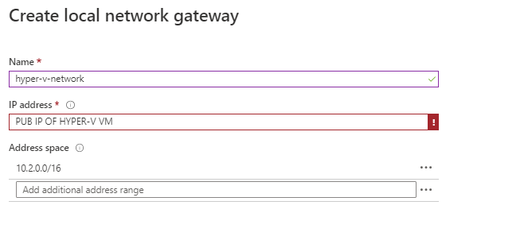

* Configure a new VPN gateway connection as below (Note down Shared key as it will be used on hyper-v VM later)

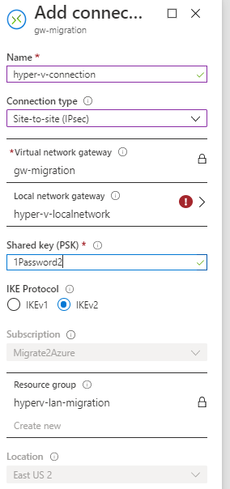

Open Routing and remote access on Hyper-V VM

* Network interfaces -> New-Demand dial interface

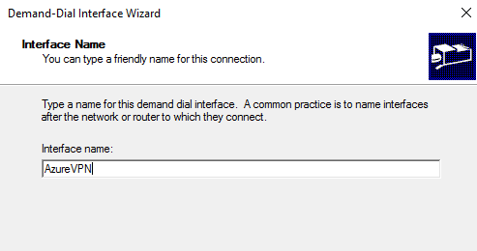

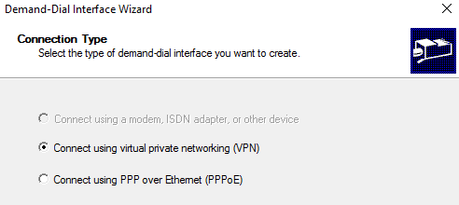

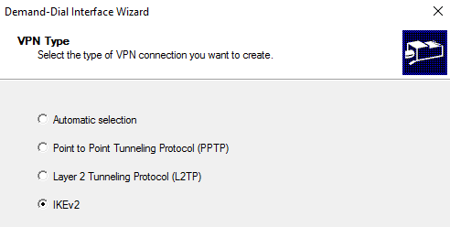

Public IP of Azure VPN Gateway to be added

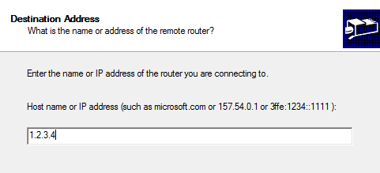

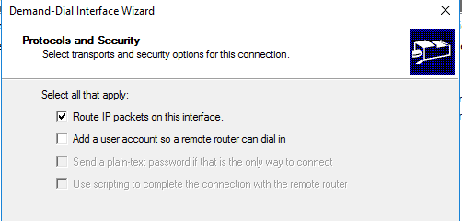

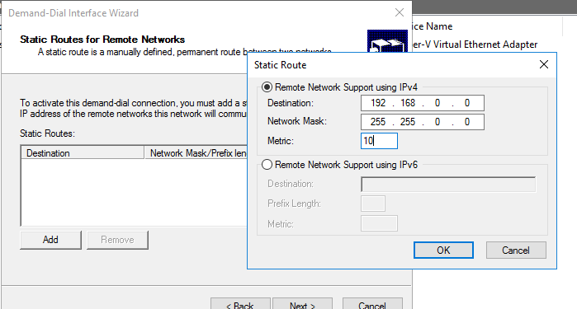

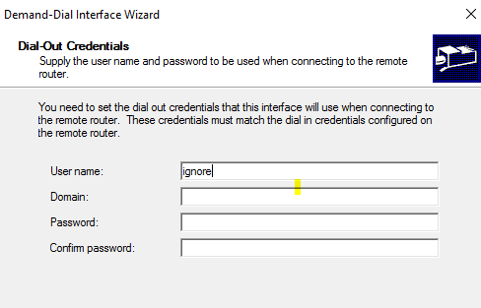

Click Finish

Right click on new interface -> properities -> security and enter the VPN GW connection key you created earlier

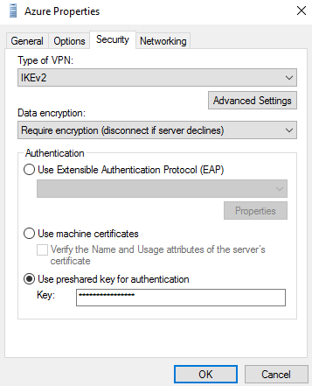

Right click on device and connect

1. Follow Instructor notes.docx
   1. Setup Create the Azure Migrate project and add assessment and migration tools (Migration VM already on Hyper-V just follow instructions to configure with Azure subscription
   2. Configure a server assessment and setup dependency view pre-requirements
   3. Configure and setup Log analytics and dependency agent on each Windows VM & Ubuntu VM that will be planned to be migrated

Discover & assessment setup

**Create the Azure Migrate project and add assessment and migration tools**

1. Open your browser, navigate to [**https://portal.azure.com**](https://portal.azure.com/), and log in with your Azure subscription credentials.
2. Select **All services**, then search for and select **Azure Migrate** to open the Azure Migrate Overview blade, shown below.

[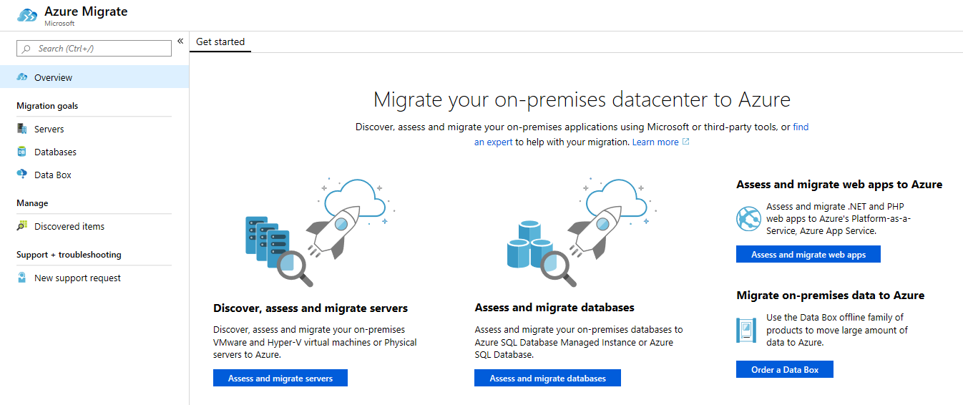](https://github.com/microsoft/MCW-Line-of-business-application-migration/blob/master/Hands-on%20lab/images/Exercise1/azure-migrate-overview.png)

1. Select **Assess and migrate servers**, then **Add tool(s)**, to open the **Add a tool** wizard at the **Migrate project** step. Select your subscription and create a new resource group named **<ResourceGroup>**. Enter **<MigrationName>** as the Migrate project name, and choose a geography close to you to store the migration assessment data.

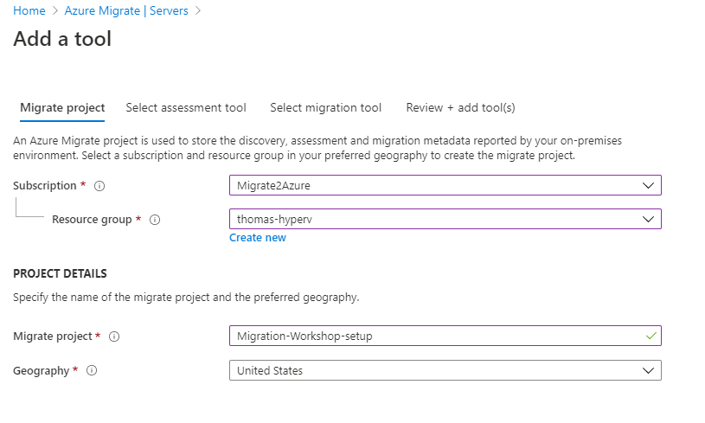

1. At the **Select assessment tool** step, select **Azure Migrate: Server Assessment**, then select **Next**.

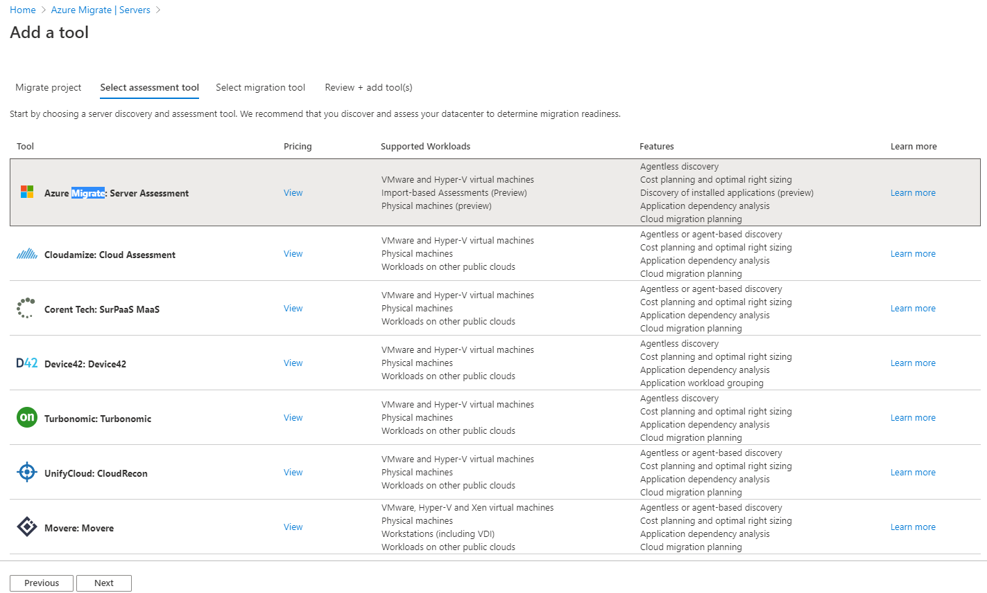

1. At the **Select migration tool** step, select **Azure Migrate: Server Migration**, then select **Next**.

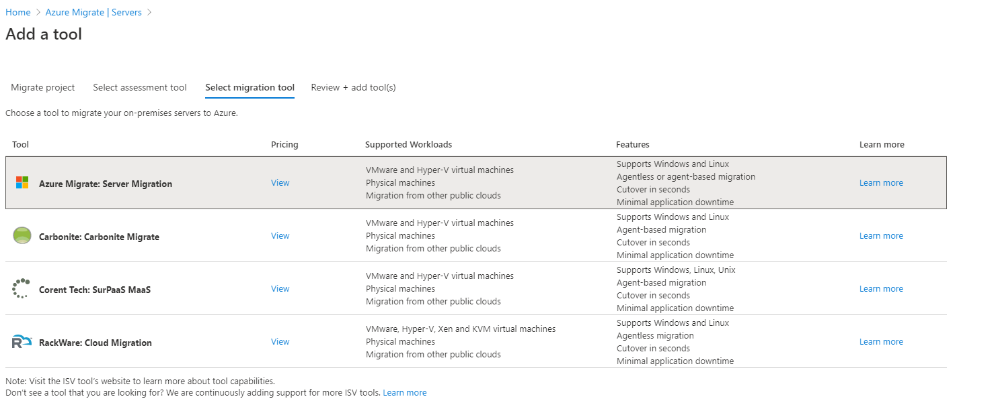

1. At the **Review + add tool(s)** step, review the settings and select **Add tool(s)**.

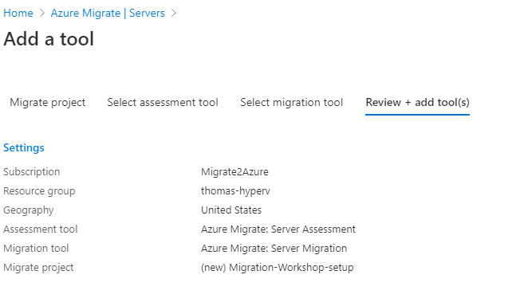

1. The Azure Migrate deployment will start. Once it has completed, select the **Servers** panel of the Azure Migrate blade (it may open automatically). You should now see the **Azure Migrate: Server Assessment** and **Azure Migrate: Server Migration** panels for the current migration project, as shown below.

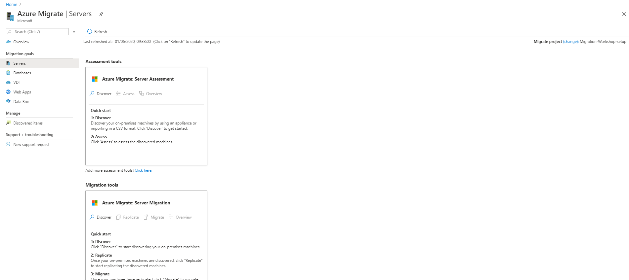

### Task 2: Deploy the Azure Migrate appliance

Select **Discover** under **Azure Migrate: Server Assessment** to open the **Discover machines** blade. Under **Are your machines virtualized?**, select **Yes, with Hyper-V**.

[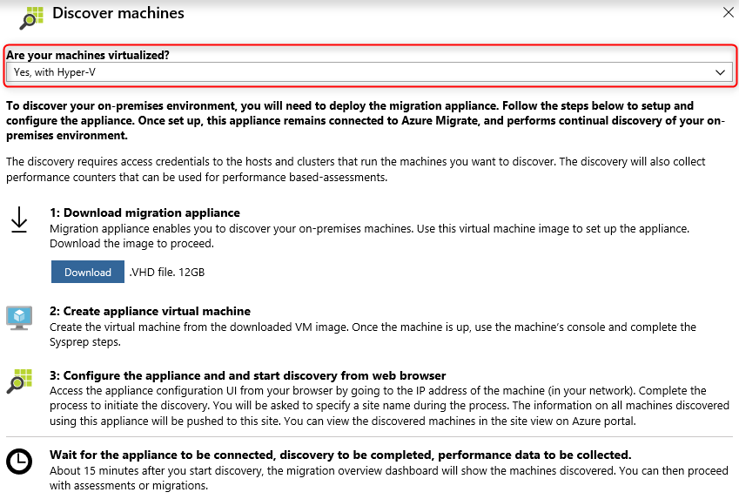](https://github.com/microsoft/MCW-Line-of-business-application-migration/blob/master/Hands-on%20lab/images/Exercise1/discover-machines.png)

Read through the instructions on how to download, deploy and configure the Azure Migrate appliance. Close the 'Discover machines' blade (do **not** download the .VHD file, it has already been downloaded for you in E:\AzureMigrationVM and pre-configured Hyper-V VM has been setup – just start VM).

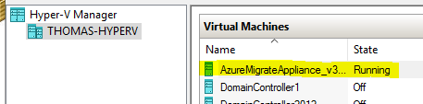

### Configure the Azure Migrate appliance

In Hyper-V Manager, select the **AzureMigrateAppliance** VM, then select **Connect**.

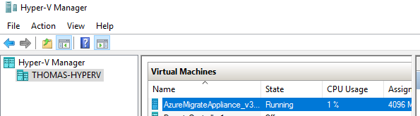

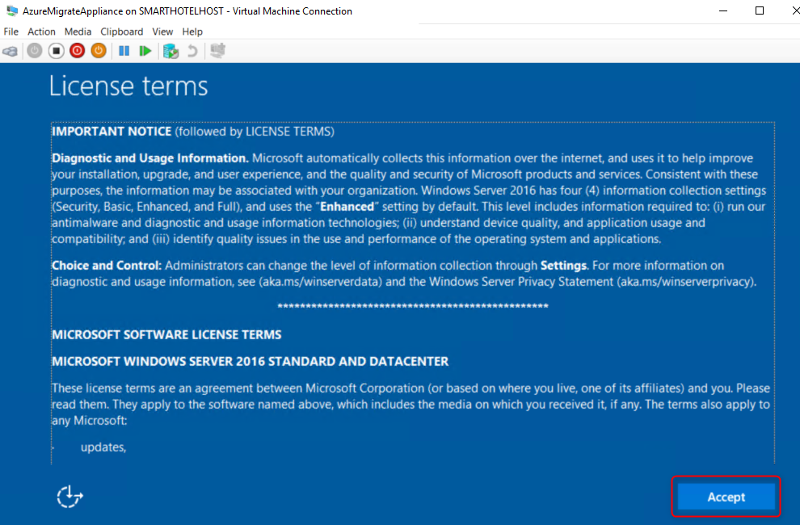

On the 'Customize settings' screen, set the Administrator password to **Password123!** (twice). Then select **Finish**.

1. At the **Connect to AzureMigrateAppliance** prompt, set the appliance screen size using the slider, then select **Connect**.
2. Log in with the Administrator password **Password123!** (the login screen may pick up your local keyboard mapping, use the 'eyeball' to check).
3. **Wait.** After a minute or two, an Internet Explorer windows will open showing the Azure Migrate appliance configuration wizard. If the **Set up Internet Explorer 11** prompt is shown, select **OK** to accept the recommended settings. If the Internet Explorer 'Content from the website listed below is being blocked...' prompt is shown, select **Close** and return to the Azure Migrate Appliance browser tab.
4. [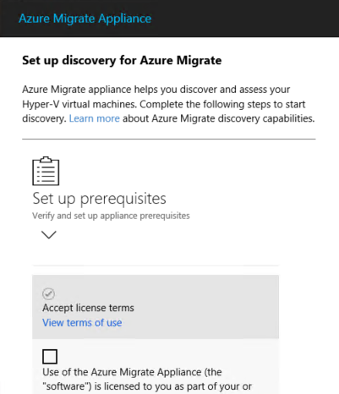](https://github.com/microsoft/MCW-Line-of-business-application-migration/blob/master/Hands-on%20lab/images/Exercise1/appliance-config-1.png)
5. Under **Set up prerequisites**, accept the license terms. The following two steps to verify Internet connectivity and time synchronization should pass automatically.

[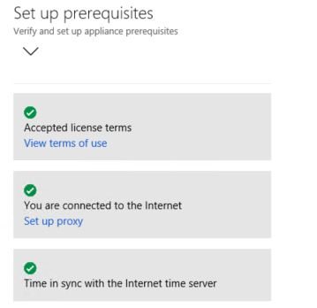](https://github.com/microsoft/MCW-Line-of-business-application-migration/blob/master/Hands-on%20lab/images/Exercise1/appliance-config-2.png)

1. **Wait** while the wizard installs the latest Azure Migrate updates. If prompted for credentials, enter user name **Administrator** and password **Password123!**. Once the Azure Migrate updates are completed, check at the top of the browser window to see if a management app restart is required, and if so, select the link to restart the app.

[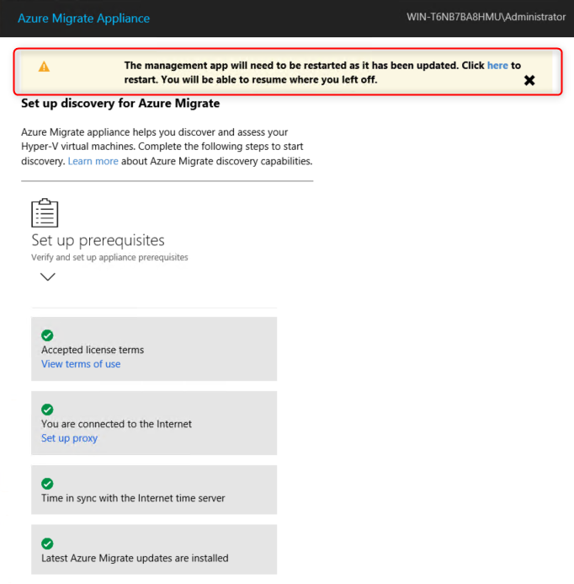](https://github.com/microsoft/MCW-Line-of-business-application-migration/blob/master/Hands-on%20lab/images/Exercise1/appliance-config-3a.png)

Once restarted, repeat the steps above to complete the 'Set up prerequisites' phase of the Azure Migrate wizard. Select **Continue** to proceed.

1. Once restarted, repeat the steps above to complete the 'Set up prerequisites' phase of the Azure Migrate wizard. Select **Continue** to proceed.

[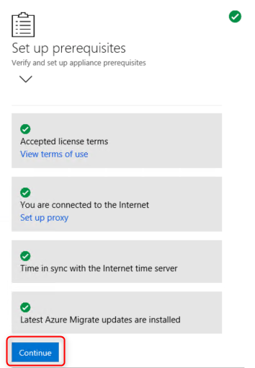](https://github.com/microsoft/MCW-Line-of-business-application-migration/blob/master/Hands-on%20lab/images/Exercise1/appliance-config-3b.png)

1. At the next phase of the wizard, **Register with Azure Migrate**, select **Login**. This opens a separate browser tab where you enter your Azure subscription credentials.
2. Once you have logged in, return to the Azure Migrate Appliance tab and select your subscription and the **Migrate Project** Migrate project using the drop-downs. Enter **APPLIANCE_NAME** as the appliance name, then select **Register**. After a short pause, the registration should be successful. Select **Continue**.

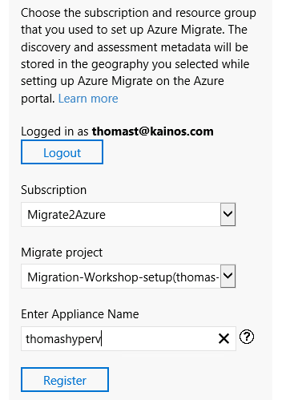

In the next step, **Provide Hyper-V hosts details**, enter the user name **tamops** and password **Password123#!**. These are the credentials for the Hyper-V host. Enter **Host login** as the friendly name, then select **Save details**.

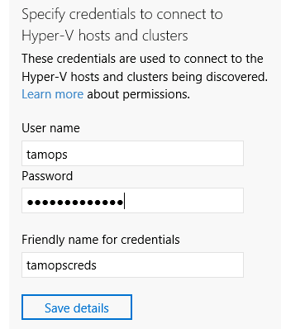

1. The next step is to register the Hyper-V host with the Azure Migrate appliance.
2. Under 'Specify the list of Hyper-V hosts and clusters to discover', select **Add**.

[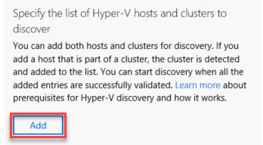](https://github.com/microsoft/MCW-Line-of-business-application-migration/blob/master/Hands-on%20lab/images/Exercise1/appliance-config-6.png)

1. A window will appear prompting for a list of Hyper-V hosts. Enter the Hyper-V hostname, **THOMAS-HYPERV**. Then select **Validate**.

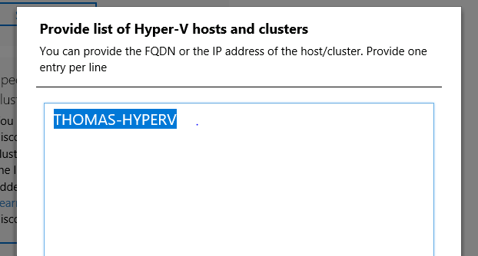

A table shows the SmartHotelHost, with status 'green'. Select **Validate** again, and check the status stays green. Then select **Save and start discovery**.

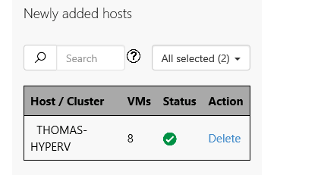

1. A message 'Initiating discovery and configuring appliance' is shown.

[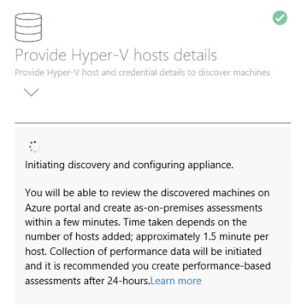](https://github.com/microsoft/MCW-Line-of-business-application-migration/blob/master/Hands-on%20lab/images/Exercise1/appliance-config-9a.png)

1. **Wait** for the Azure Migrate status to show 'Created Site and initiating discovery'. This will take several minutes.

[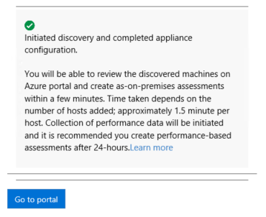](https://github.com/microsoft/MCW-Line-of-business-application-migration/blob/master/Hands-on%20lab/images/Exercise1/appliance-config-9b.png)

Return to the **Azure Migrate** blade in the Azure portal. Select **Servers**, then select **Refresh**. Under **Azure Migrate: Server Assessment** you should see a count of the number of servers discovered so far. If discovery is still in progress, select **Refresh** periodically until 5 discovered servers are shown. This may take several minutes.

### Configure dependency visualization

Each VM needs the agent installed

When migrating a workload to Azure, it is important to understand all workload dependencies. A broken dependency could mean that the application doesn't run properly in Azure, perhaps in hard-to-detect ways. Some dependencies, such as those between application tiers, are obvious. Other dependencies, such as DNS lookups, Kerberos ticket validation or certificate revocation checks, are not.

In this task, you will configure the Azure Migrate dependency visualization feature. This requires you to first create a Log Analytics workspace, and then to deploy agents on the to-be-migrated VMs.

Return to the **Azure Migrate** blade in the Azure Portal, and select **Servers**. Under **Azure Migrate: Server Assessment** select **Groups**, then select the **Migration Workshop set VMs** group to see the group details. Note that each VM has their **Dependencies** status as **Requires agent installation**. Select **Requires agent installation** for the **smarthotelweb1** VM.

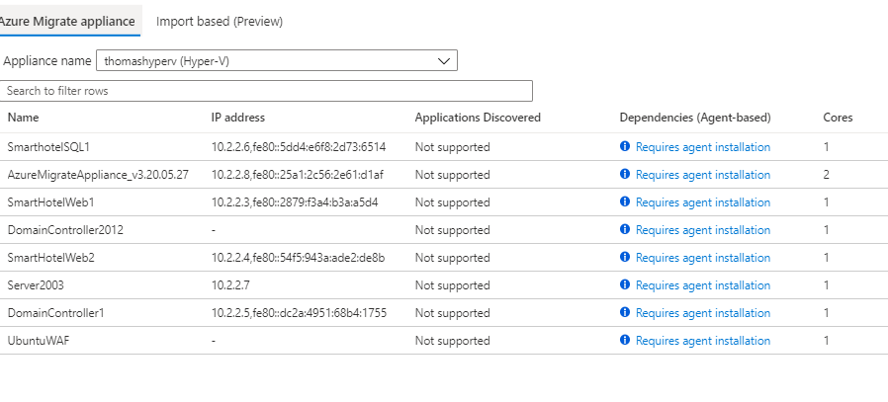

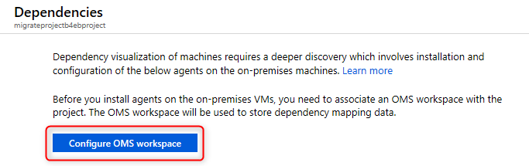

Configure Log analytics as required and note down workspace ID & Key

867d62cc-1adc-41e6-88c8-813d2a38eb3d

f3kUrqLCOt4n9iJn5Lf//gNQXx1pAoLlKQ3QVi8pHU1ddm+D8r9/IU4sKwzK8ZTR2/LBRDOMn13SZ2G6QV58vA==

**Setup for each Windows VM**

1. Select through the installation wizard until you get to the **Agent Setup Options** page. From there, select **Connect the agent to Azure Log Analytics (OMS)** and select **Next**. Enter your Workspace ID and Workspace Key on the next page, and select **Azure Commercial** from the Azure Cloud drop-down. Select through the remaining pages and install the agent.

[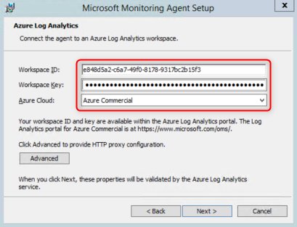](https://github.com/microsoft/MCW-Line-of-business-application-migration/blob/master/Hands-on%20lab/images/Exercise1/mma-wizard.png)

1. Paste the following link to the Dependency Agent Windows installer into the browser address bar. **Run** the installer and select through the install wizard to complete the installation.
2. https://aka.ms/dependencyagentwindows

[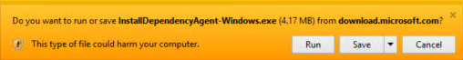](https://github.com/microsoft/MCW-Line-of-business-application-migration/blob/master/Hands-on%20lab/images/Exercise1/da-win-run.png)

1. Close the virtual machine connection window for the **smarthotelweb1** VM. Connect to the **smarthotelweb2** VM and repeat the installation process for both agents (the administrator password is the same as for smarthotelweb1).

You will now deploy the Linux versions of the Microsoft Monitoring Agent and Dependency Agent on the UbuntuWAF VM.

**Setup Linux**

**Apt-get update**

**Apt-get install curl**

1. Enter the following command to connect to the **UbuntuWAF** VM running in Hyper-V on the SmartHotelHost:

ssh demouser@192.168.0.8

1. Enter 'yes' when prompted whether to connect. Use the password **demo!pass123**.

[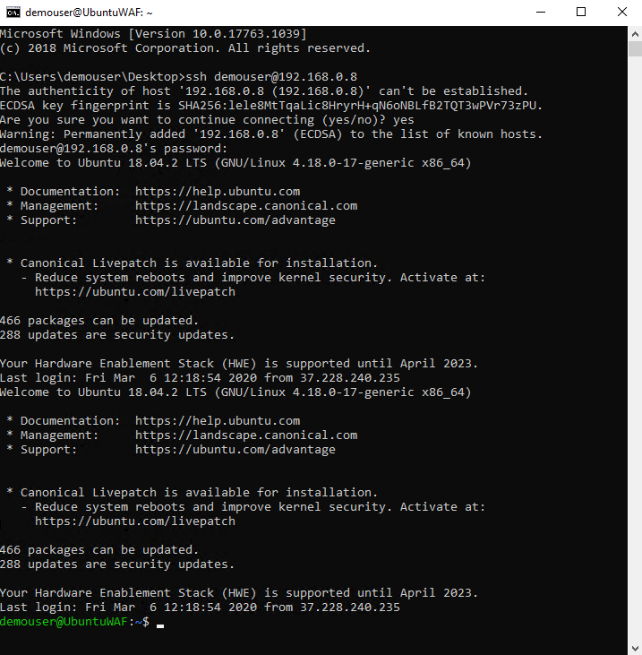](https://github.com/microsoft/MCW-Line-of-business-application-migration/blob/master/Hands-on%20lab/images/Exercise1/ssh.png)

1. Enter the following command, followed by the password **demo!pass123** when prompted:

sudo -s

This gives the terminal session elevated privileges.

1. Enter the following command, substituting <Workspace ID> and <Workspace Key> with the values copied previously. Answer when prompted to restart services during package upgrades without asking.

wget https://raw.githubusercontent.com/Microsoft/OMS-Agent-for-Linux/master/installer/scripts/onboard_agent.sh && sh onboard_agent.sh -w c563dcbb-bb7a-4b7d-9a81-a78e8fcfcfe5 -s

1. Enter the following command, substituting <Workspace ID> with the value copied previously:

/opt/microsoft/omsagent/bin/service_control restart <Workspace ID>

1. Enter the following command. This downloads a script that will install the Dependency Agent.

wget --content-disposition https://aka.ms/dependencyagentlinux -O InstallDependencyAgent-Linux64.bin

1. Install the dependency agent by running the script download in the previous step.

sh InstallDependencyAgent-Linux64.bin -s

[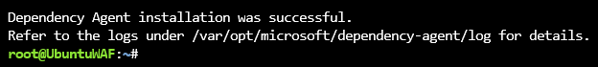](https://github.com/microsoft/MCW-Line-of-business-application-migration/blob/master/Hands-on%20lab/images/Exercise1/da-linux-done.png)

1. The agent installation is now complete. Next, you need to generate some traffic on the SmartHotel application so the dependency visualization has some data to work with. Browse to the public IP address of the SmartHotelHost, and spend a few minutes refreshing the page and checking guests in and out.

### Explore dependency visualization

**Create a group: SmartHotelMigration** select VMs to be included

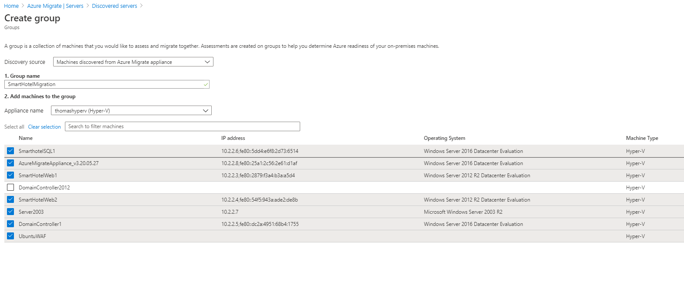

### Task 3: Register the Hyper-V Host with Azure Migrate Server Migration

In this task, you will register your Hyper-V host with the Azure Migrate: Server Migration service. This service uses Azure Site Recovery as the underlying migration engine. As part of the registration process, you will deploy the Azure Site Recovery Provider on your Hyper-V host.

1. Return to the **Azure Migrate** blade in the Azure Portal, and select **Servers**. Under 'Migration Tools', select **Discover**.

[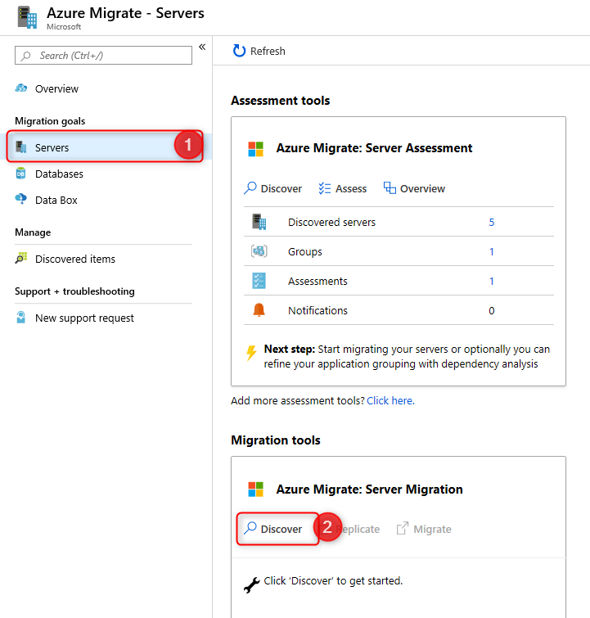](https://github.com/microsoft/MCW-Line-of-business-application-migration/blob/master/Hands-on%20lab/images/Exercise3/discover-1.png)

1. In the **Discover machines** panel, under **Are your machines virtualized**, select **Yes, with Hyper-V**. Under **Target region** enter **the same region as used for your Azure SQL Database** and check the confirmation checkbox. Select **Create resources** to begin the deployment of the Azure Site Recovery resource used by Azure Migrate: Server Migration for Hyper-V migrations.

[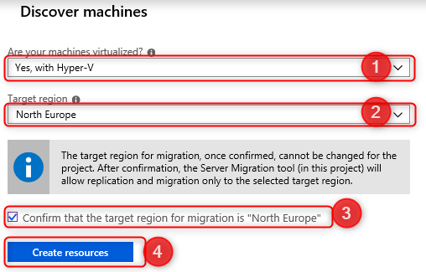](https://github.com/microsoft/MCW-Line-of-business-application-migration/blob/master/Hands-on%20lab/images/Exercise3/discover-2.png)

Once deployment is complete, the 'Discover machines' panel should be updated with additional instructions.

1. Copy the **Download** link for the Hyper-V replication provider software installer to your clipboard.

[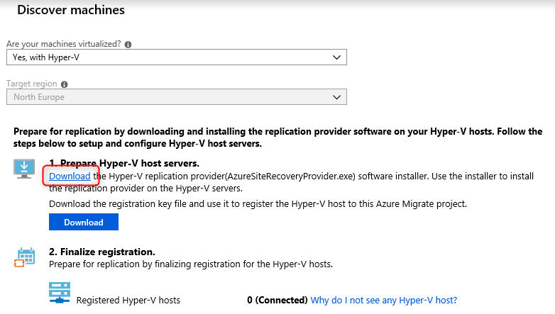](https://github.com/microsoft/MCW-Line-of-business-application-migration/blob/master/Hands-on%20lab/images/Exercise3/discover-3.png)

1. Open the **SmartHotelHost** remote desktop window, launch **Chrome** from the desktop shortcut, and paste the link into a new browser tab to download the Azure Site Recovery provider installer.
2. Return to the **Discover machines** page in your browser (outside the **Hyper-V host**  remote desktop session). Select the **Download** button and download the registration key file.

[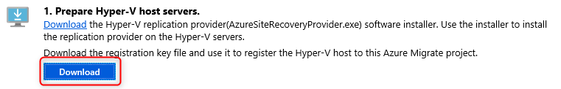](https://github.com/microsoft/MCW-Line-of-business-application-migration/blob/master/Hands-on%20lab/images/Exercise3/discover-4.png)

1. Open the file location in Windows Explorer, and copy the file to your clipboard. Return to the **Hyper-V host** remote desktop session and paste the file to the desktop.
2. Still within the **Hyper-V host**  remote desktop session, open the **AzureSiteRecoveryProvider.exe** installer you downloaded a moment ago. On the **Microsoft Update** tab, select **Off** and select **Next**. Accept the default installation location and select **Install**.

[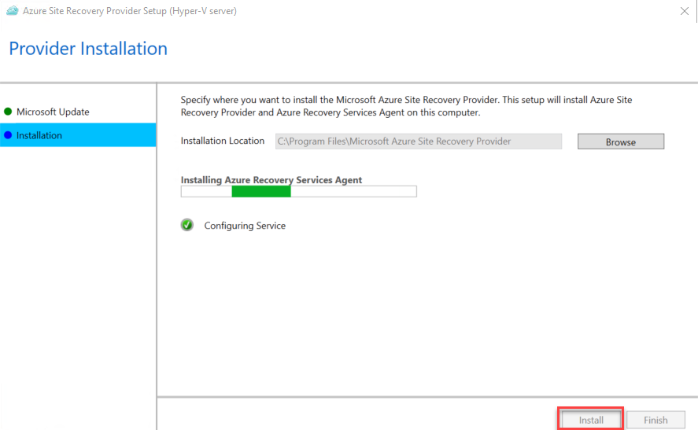](https://github.com/microsoft/MCW-Line-of-business-application-migration/blob/master/Hands-on%20lab/images/Exercise3/asr-provider-install.png)

1. When the installation has completed select **Register**. Browse to the location of the key file you downloaded. When the key is loaded select **Next**.

[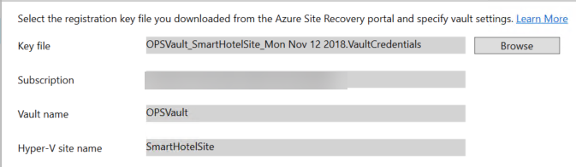](https://github.com/microsoft/MCW-Line-of-business-application-migration/blob/master/Hands-on%20lab/images/Exercise3/asr-registration.png)

1. Select **Connect directly to Azure Site Recovery without a proxy server** and select **Next**. The registration of the Hyper-V host with Azure Site Recovery will begin.
2. Wait for registration to complete (this may take several minutes). Then select **Finish**.

[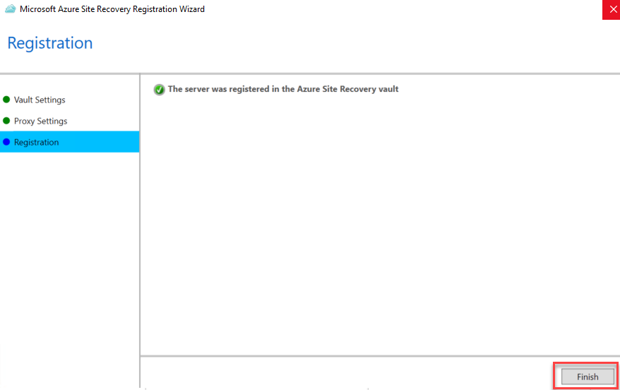](https://github.com/microsoft/MCW-Line-of-business-application-migration/blob/master/Hands-on%20lab/images/Exercise3/asr-registered.png)

1. Minimize the **Hyper-V host**  remote desktop session and return to the Azure Migrate browser window. **Refresh** your browser, then re-open the **Discover machines** panel by selecting **Discover** under **Azure Migrate: Server Migration** and selecting **Yes, with Hyper-V** for **Are your machines virtualized?**.
2. Select **Finalize registration**, which should now be enabled.

[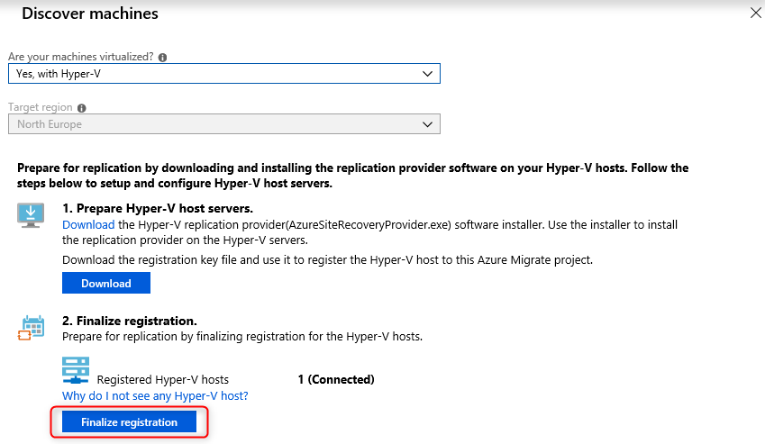](https://github.com/microsoft/MCW-Line-of-business-application-migration/blob/master/Hands-on%20lab/images/Exercise3/discover-5.png)

1. Azure Migrate will now complete the registration with the Hyper-V host. **Wait** for the registration to complete. This may take several minutes.

[](https://github.com/microsoft/MCW-Line-of-business-application-migration/blob/master/Hands-on%20lab/images/Exercise3/discover-6.png)

1. Once the registration is complete, close the **Discover machines** panel.

[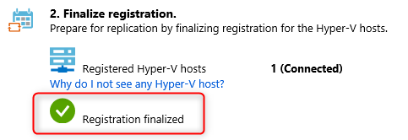](https://github.com/microsoft/MCW-Line-of-business-application-migration/blob/master/Hands-on%20lab/images/Exercise3/discover-7.png)

1. The **Azure Migrate: Server Migration** panel should now show 5 discovered servers.

## Migrate the application and web tiers using Azure Migrate: Server Migration

In this exercise you will migrate the web tier and application tiers of the application from on-premises to Azure using Azure Migrate: Server Migration.

1. Storage account:-

Storage Account:- thomashypervmigrationsa already created via Terraform in resource group

1. Virtual Network

Virtual network:- landing-zone-migration created via Terraform

1. Enable replication from hyper-v to Azure Migrate

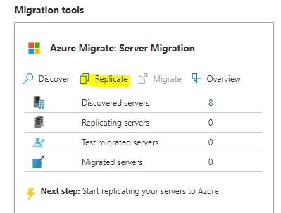

In the **Source settings** tab, under **Are your machines virtualized?**, select **Yes, with Hyper-V** from the drop-down. Then select **Next: Virtual machines**.

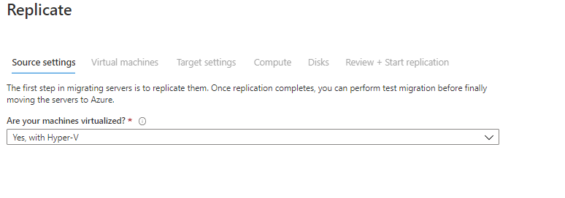

For this exercise, do not specify assessment

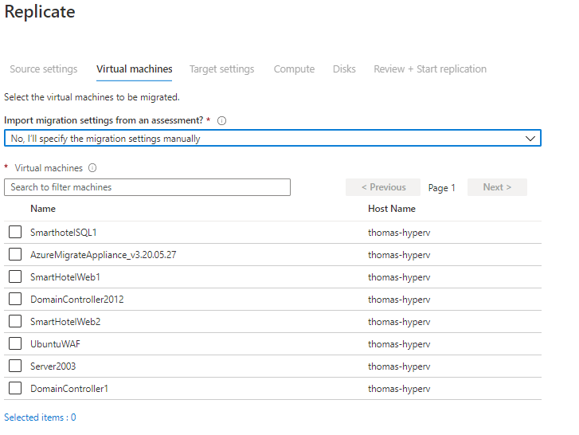

Select Application VMs you want to migrate

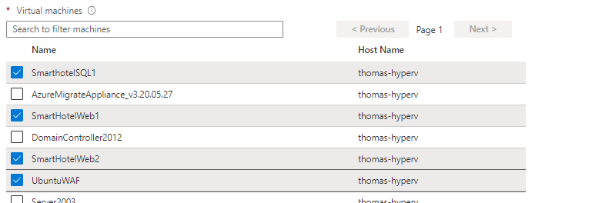

Configure target settings as below

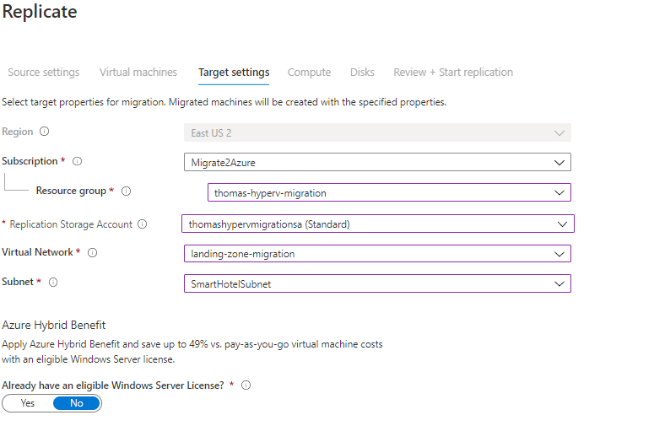

Replicate settings as below (B2s for this exercise to reduce cost)

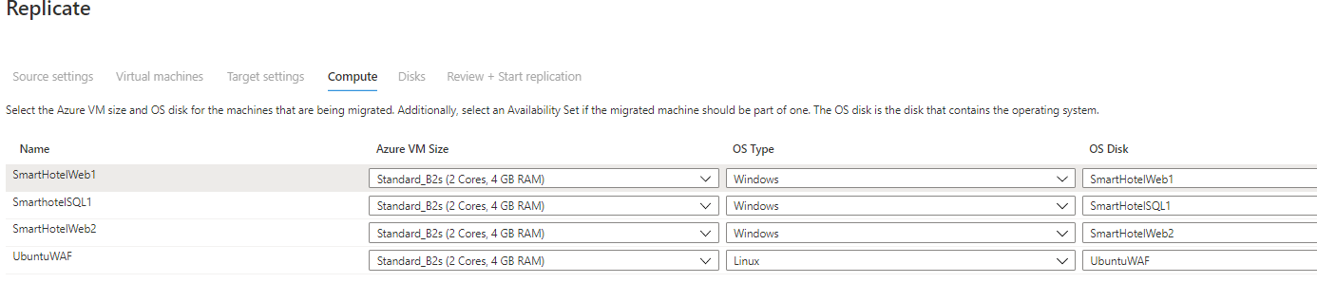

Disk settings (all)

